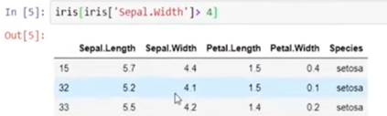

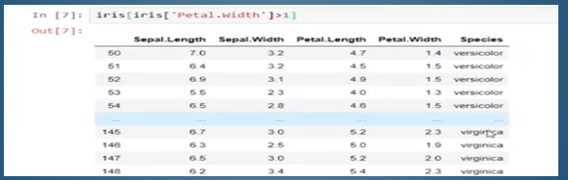

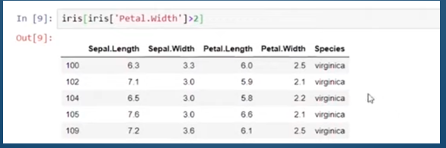

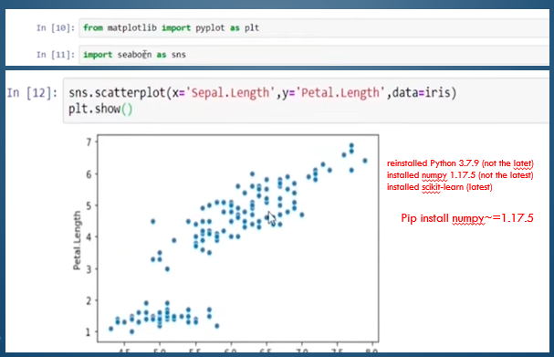

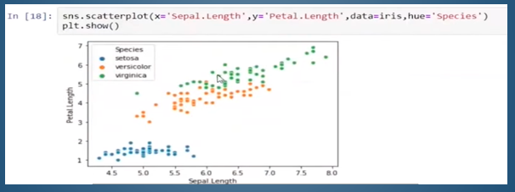

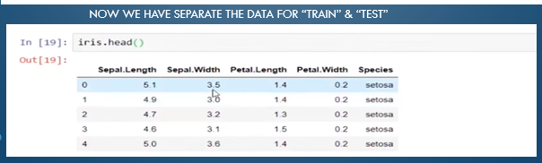

C:\> pip install matplotlib

Numpy

Pandas

Matplotlib

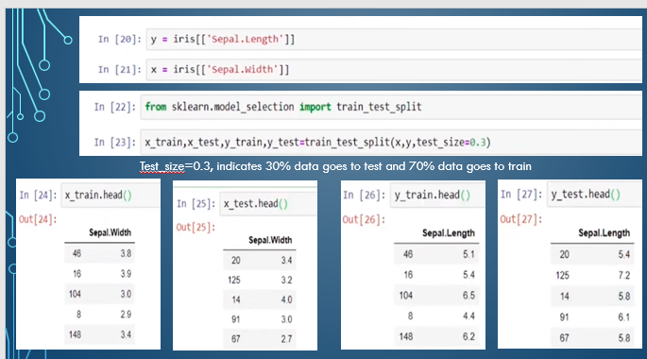

NOTE: ANALYSE, IMPLEMENT AND CONDUCT DEEP STUDY + OUTPUT, SUBMIT THE RESULTS TO Internship@glowlogics.in

